Latency patterns:

Fixed latency:
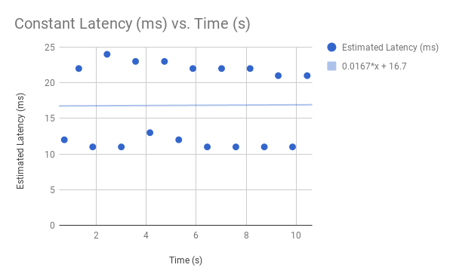
This latency pattern resulted in relatively stable behavior with minor, regularly distributed variations due to internet causes. When we set the fixed latency to a higher value, clients found input to be noticeably sluggish or entirely fine, depending on the value to which we set the latency. Regardless of this value, the quality of the play experience was about constant, as the latency itself hardly changed from the preset value, allowing players to get used to the delay.

Random Latency:
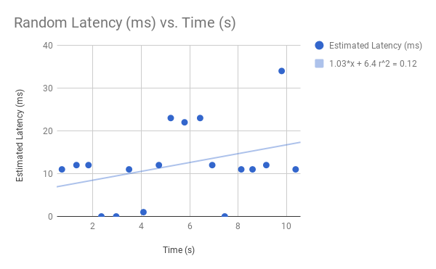
We set the latency range between 0 and 50 according to a uniform random distribution function. The paddles’ reaction speed are fluctuating between instant to 1/20th of a second delay. Despite the small range, the movement felt inconsistent because it sometimes started instantly, and sometimes hesitates, leading players to not be able to anticipate it. We can also see some small “glitching” from the ball. As the latency influences when the client receives data back from the server and therefore influences the client side refresh rate of the play space.

Incremental Latency:
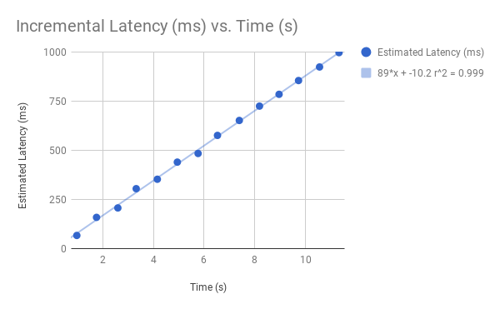
We incremented the latency number from 0 to 1000. This version of the latency pattern was the most interesting in our opinion as we got to play the game while noticing the quality of play deteriorate. At first the game felt acceptable to play but that quickly changes as the latency increases and the game becomes unplayable.

